MEETING TITLE: | City of Seguin – Cordova Rd Reconstruction  30% Review Meeting |  | DATE: | 09/15/2023
PROJECT NUMBER: | 12775-00
AGENDA TOPICS:

General Project |  | - Schedule  - 60% DDRT – 11/9/23  - 10/26/23 submittal  - 90% - 3/14/24  - ROW/Utility pause*  - 100%-7/3/25  - Letting – 11/3/25  - *ROW/utility pause is dependent on ENV clearance and ROW acquisition. In depth discussion later  - Funding  - AFA- $24,704,302  - 30% OPCC- $37,914,677.62  - Includes $1.8 M in ROW  - Does not include utility or easement acquisition cost  - Overrun- $13,210,375.62  - TIP amendment  - Memo written in Aug 2022, with $37.3 M estimate, to support funding amendment  - Letting date amendment- CoS to supply schedule (see schedule section)  - TxDOT Projects  - SH 46 – CSJ 0216-02-067  - Let Date: 09/01/2034 – TxDOT has stated this is not an approved project and should not be shown on any documents  - Scope: Construct Freeway Facility  - Limits: IH 35 to IH 10  - Provided public meeting comments and design files  - SH 123- CSJ 0366-02-089  - Let Date: 09/04/2025  - Design schedule has been request without receipt  - Scope: Reconstruct Roadway from Two-Lane to Four-Lane Divided Highway  - Limits: Cordova Rd to IH 10
Studies |  | - Traffic study and projections  - TxDOT agreed to methodology  - Only comment was to revise design year from letting year to opening year  - Projections will now be 2048, 2058  - Report is currently in review and will be submitted to TxDOT within two weeks  - TxDOT has Option C approval letter drafted  - SAT to request ESAL from Austin (~6 months).  - Geotechnical  - Draft pavement sections in use, pending finalization of ESALs  - TxDOT offered PDCC meeting- CoS preference?  - 30% design pavement section- Flexible  - 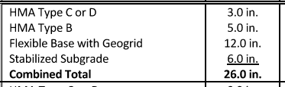  - With this pavement section the geotechnical engineer recommends extending curb and gutter section through flexible base (20” thickness- not in 30% plans)  - Geotech recommends this to prevent lateral moisture infiltration  - Shallow ditches  - Standing water  - 30% design has curb and gutter extending through HMAC TY-B (8” thickness)  - Alternatives  - Provided 2’ flex base offset from BOC  - Lateral moisture barriers  - Concrete pavement (eliminate untreated flex base)  - Concrete pavement option  - 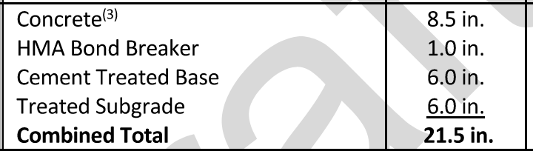  - Cost comparison  - HMAC section - $11 M (without extended curb and gutter)  - ~$1M addition for extending curb and gutter through base  - Concrete section - $12 M  - Life cycle cost  - HMAC vs CONC routine maintenance- even (crack seal/seal coat vs joint sealing, etc)  - 30-year life cycle  - HMAC- 2- 3” mill and overlays- $6 M (Today dollars) (excluding engineering, inspection, mobilization, etc)  - Conc- Minimal
ENV / Public Involvement |  | - Environmental  - Design team has submitted to TxDOT:  - Project descriptions for ECOS scoping  - CE classification request (>30 AC)  - District approved  - Submitted to ENV Division for final approval: “Behind”  - Historical Project Coordination Request (PCR)  - District verbal approval  - Cannot submit to ENV Division until CE is approved  - TxDOT suggested not holding public meeting until 4F properties are clear  - ENV partner has studied and does not anticipate 4F impacts  - CE- Supporting studies have been started, pending acceptance of CE  - Public Involvement  - Public meeting  - Must submit notice to TxDOT at least 30 days prior  - Tentatively identified 10/26 and 11/2 for public meeting  - CoS reserved operations center  - Other planed outreach by city  - Webpage, mail notices, email campaigns, social media posts, etc  - Public meeting materials  - Schematic  - PowerPoint, etc?  - Stakeholder engagement  - Coordinate meeting with Mr. Bartoskewitz prior to public meeting
ROW Acquisition |  | - Final TROE’s received and special instructions for restricted parcels received this week.  - Survey Progress  - 44 impacted parcels, 1 drainage easement  - 36 have completed survey (remaining will be completed with recent TROE)  - 6 legal descriptions in in QAQC- will send one for city review/approval  - Survey/Legal description scope  - 30 parcels were scoped as an assumption  - 45 known and being processed at this time  - Potential for additional with utility easement impacts
Schedule |  | - Discuss multi-discipline schedule (separate attachment)  - Discuss PUA usage
Roadway Design |  | - ROW  - Acquisition- 37.5 AC  - Width- 120’ min, typically varies 120’-160’, 190’ max (substation)  - At SH 46  - Triangle and “Old Cordova”  - Utilities are curious about old Cordova ROW  - At GVEC/SH 123  - Triangles and “Old Cordova”  - Cul-de-sac vs leave open  - Leave exist pavement vs reconstruct  - TxDOT Comments  - Primarily information added with future submittal (traffic signals, sidewalk details, detailed curb ramps, etc)  - Turn lane taper lengths- criteria for 40 mph is 50’, TxDOT recommends 100’- CoS preference?  - Super elevation  - CoS criteria for 40 mph is 770’ min radius with no super- this meets TxDOT/AASHTO for low speed urban with no super. RDM table 2-3  - TxDOT continues to request super elevation  - 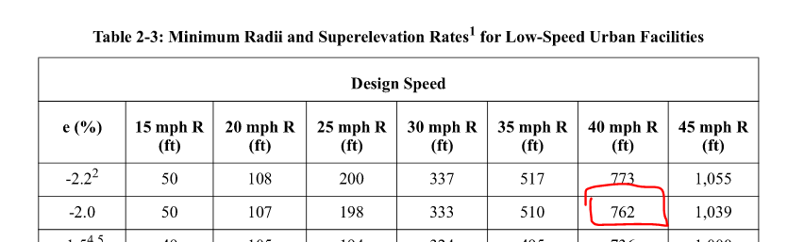  - Requested removal of curb and gutter (curb)- maintaining curb and gutter per CoS criteria  - Requested vertical curves for 1% grade break- meets criteria  - CoS Comments  - Shared use path placement  - Culvert crossings  - At SH 46. Tying into SH 46 raises PGL well above ROW elevation and requires fill slope. Review cross sections  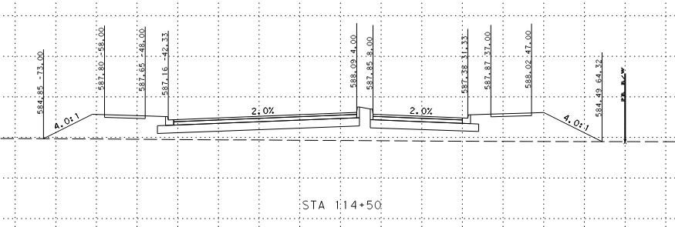  - Shared use path buffer decreased to 5’ to reduce culvert length and increase hydraulic efficiency.  - Areas where ditch flow>capacity with SUP at ROW..typically at culvert approaches. Also allow water to get into upstream end of culvert without storm drain  - Profile  - Currently meeting CoS 0.5% min every where except near Huber/The Summit  - Saw tooth design due to the flat terrain (0.3% typ)  - Interval is currently 150’-200’, preference is to get 300’ minimum  - Reduced longitudinal slopes in areas  - Right turn lanes  - Design workshop- direction was to plan row/drainage for all needed turn lanes  - In 30% plans all turn lanes/development connections are shown as proposed  - With multiple delays with development (water-2026), should we show as proposed, greyed back as future, or not show with potential change order during construction?  - Raised median will be grass except in reduced with areas.
Drainage |  | - Design criteria  - Ditches/driveway culvers- 10 yr  - Crossings- 25 yr with 6” freeboard  - Proposed conditions- ultimate development ignoring upstream detention  - Driveways  - Cover is difficult  - 18” pipe in cases to fit (24” arch equivalent in cases)  - The Summit and Cordova Trails drainage issues  - Near drainage area high  - Cordova Trails channel does not drain The Summit  - Storm drain installations at The Summit outfall and Cordova trails and eliminate ditches will drain 10 year event. Ditches also do not work at turn lanes due to constrained ROW with development  - Evaluated parallel channel, too deep to outfall/excessive length  - The Summit detention- recommend to include analysis of existing detention to avoid oversizing storm drain. Ignoring detention requires storm drain that conflicts with pavement. Initial dentition analysis shows reducing in box size  - Discuss splitting flows at “Old Cordova”  - SH 123  - Extending crossing north of Cordova in interim (TxDOT replacing)  - New proposed crossing south of Cordova (Similar to TxDOT’s plan, locations/length coordination)  - Additional coordination required  - Bridge class culverts  - Will require bridge rail/pedestrian rail  - Require PBLR review at 60% (PBLR now requiring drainage report)
Traffic Signals |  | - SH 46  - TxDOT project 2034 letting  - Design and construct permanent traffic signal  - Include in 60% plans  - SH 123  - Cordova/SH 123 have end of 2025 letting  - Further coordination with TxDOT needed  - Potential for temporary signal  - 60% plans TBD
Misc Design |  | - TCP  - Adding additional details going into 60%  - Intersection phasing  - Detours/quad phasing  - Temp drainage  - 2-year design  - Temp shoring needs  - SW3P  - Being developed for 60%  - City/County preferences?  - Sod vs seeding vs hydro-mulch, etc  - Construction schedule  - Standard work week  - Running at 17 working days per month (holidays/weather)  - 426 working days (25 months)  - May lengthen slightly with intersection phasing, more defined TCP
Utilities |  | - Completed kickoff meeting  - Requested owner information (easement documentation, conflict redlines, etc)  - Held one-on-one follow up meetings with GVEC, ATT, CoS  - GVEC  - GVEC will not begin design until NORA letter or equivalent is in place.  - Long lead time on engineered poles  - Potential major impacts to underground fiber/manholes  - Discuss NORAs  - AT&T  - AT&T stated cabinet replacement has an 18-24 month lead time.  - 7+ cabinets in project limits, most in private easements  - Most are in direct conflict with proposed roadway. May be able to design around 2  - AT&T may elect to purchase new easements- extends relocation timeline  - Summary of owners  - GVEC- Received easement documents, as-builts, redlines  - LCRA- Received easement documents, as-builts. No redlines  - CPS- Still cannot identify ownership of pipeline. Awaiting transmission line information  - Springs Hill- Received easement documents. No redlines  - AT&T- Awaiting all documents, had one-on-one to discuss concerns, working with planning  - Spectrum- Difficulty establishing contact, making progress. Documents expected 9/15/23  - Brightspeed/Lumen- No information provided, was recently informed Lumen purchased, in contact with Lumen  - Zayo- Received as-builts and redlines  - Centerpoint Gas- Block maps received. No redlines  - Exxon- Received depth and material information  - Path forward  - Review/determine compensable easements (reimbursable)  - Process redline information  - Evaluate conflict mitigation  - Have final hard conflicts requiring relocation at 60%- implementation of NORAs/Utility design begins

