CORDOVA ROAD RECOMMENDATIONS:
- SH 46 AND CORDOVA ROAD/THREE OAKS - SIGNALIZED
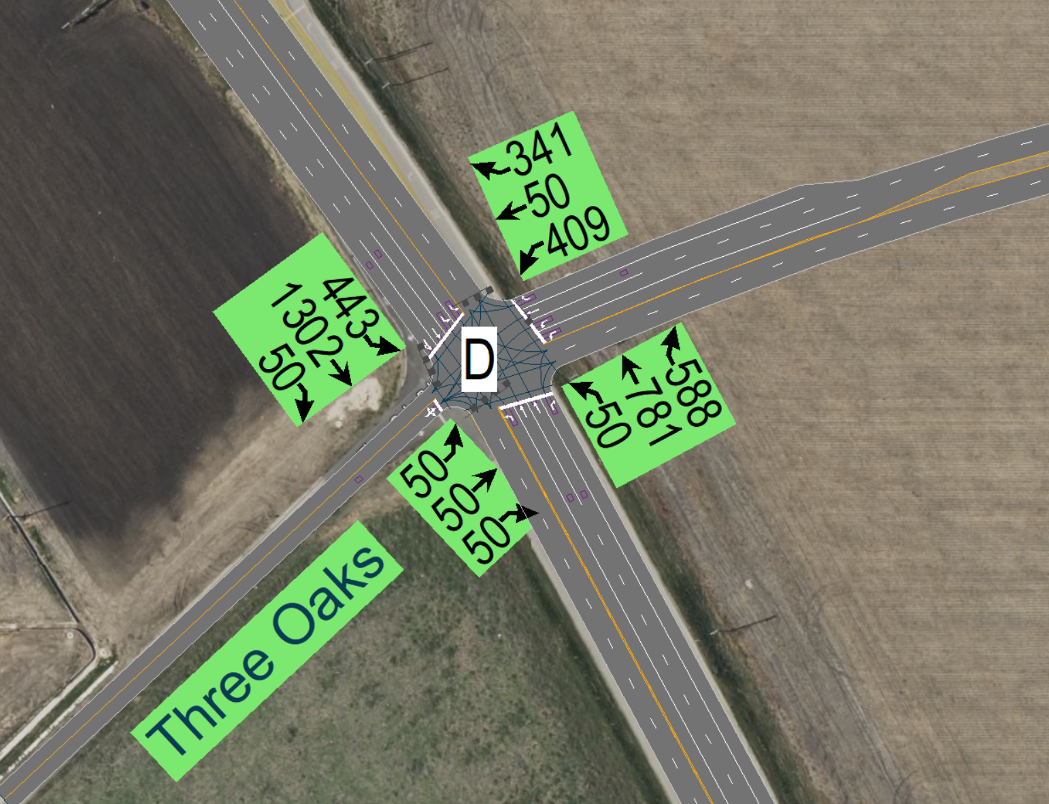
2025 AM & PM:
- Recommended lane configuration is shown in the snip above.
- Operates with an overall LOS D (AM) and LOS C (PM) with current lane improvements shown.
- WB LT lane should be a minimum 425’ in length plus 50’ of taper based on Sim Traffic Queue analysis for 40 mph design speed.
- WB RT lane should be a minimum 260’ in length plus 50’ of taper based on Sim Traffic Queue analysis for 40 mph design speed.
- NB RT Lane length should be a minimum 415’ plus 100’ of taper for 60 mph design speed.
- Additional recommendation is to increase Green time on SBL/WBL to improve overall delay and LOS in AM
2045 AM & PM:
- Recommended lane configuration is shown in the snip above.
- Operates with an overall LOS F in both AM and PM with current lane improvements shown.

- Increasing the SB LT Lane storage length to 800’ plus 200’ taper is shown to have improved queue in the AM/PM
- Queue extends to almost 975’ on WB LT. Providing a total length of minimum 500’ plus 50’ of taper kept the queue below the storage length as per Sim Traffic Queue analysis.
- WB RT lane should be a minimum 310’ in length plus 50’ of taper based on Sim Traffic Queue analysis for 40 mph design speed.
- NB RT Lane length should be a minimum 415’ plus 100’ of taper for 60 mph design speed.
- Increasing the right turn storage and taper and adding additional thru lane on NB SH 46 could improve delay and queues. However additional turn and through lanes on SH 46 were not shown since we anticipate TxDOT will widen SH 46 to a freeway and a grade separated interchange will be provided at the Cordova Road intersection. Providing four westbound approach lanes would allow easier conversion to a diamond intersection where three lane go through and one lane turns right; then under the bridge there could be Left-Left-Through or Left-left/through-right configuration which would match the TxDOT SAT Standard diamond configuration.
- Additional recommendation is to increase Green time on SBL/WBL and optimize signal timings to improve overall delay and LOS in AM/PM

- CORDOVA RD AND CORDOVA LOOP/XING – UNSIGNALIZED
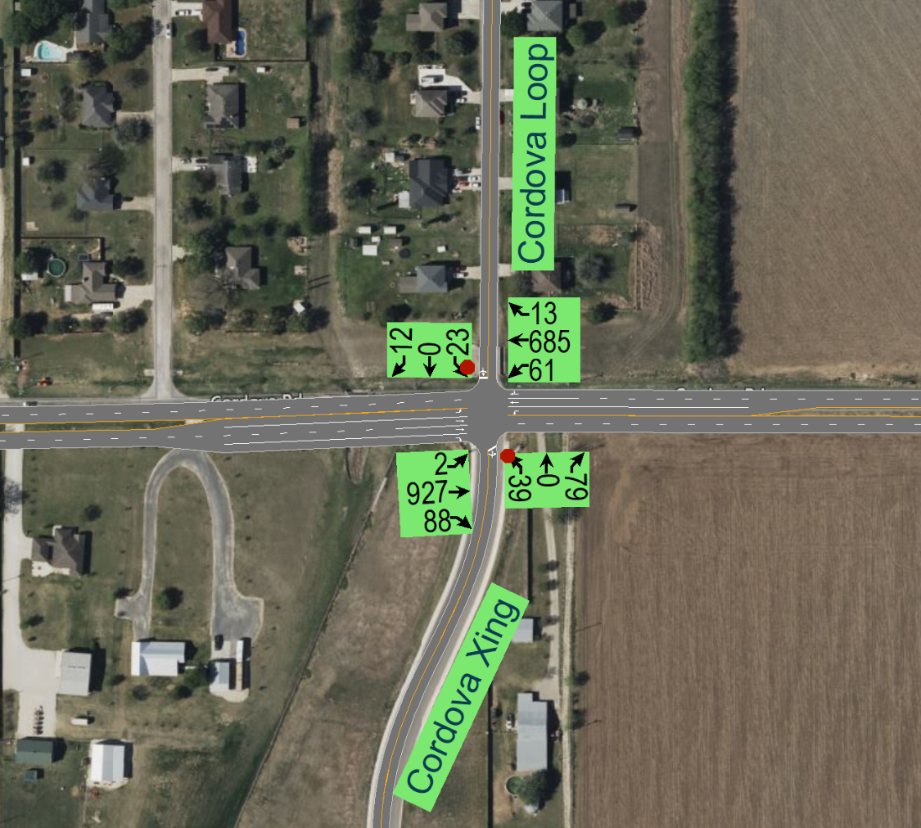
2025 AM & PM:
- Recommended lane configuration is shown in the snip above.
- Operates with an LOS A/B on Cordova Rd EB/WB and LOS F on Cordova Loop in both AM and PM. There isn’t any significant queue experienced NB/SB with current lane improvements shown, as the volumes are not high enough.
- Median opening at eastern Cordova Loop/Cordova Crossing with left-turn lanes in each direction. Left-turn lanes should be a minimum of 200’ plus 50’ of taper based on design speed of 40 mph. Due to the spacing between Cordova Loop East and West, the western portion would be limited to RIRO only.
- Provided dedicated right turn lane on EB as the Peak Hour right turn traffic > 50vph. Right turn lane should be a minimum 130’ in length plus 50’ of taper based on design speed of 40 mph.
2045 AM & PM:
- Recommended lane configuration is shown in the snip above.
- Operates with an LOS B on Cordova Rd and LOS F on Cordova Loop in both AM and PM. There isn’t any significant queue experienced NB/SB with current lane improvements shown, as the volumes are not high enough.
- Provided dedicated right turn lane on EB as the Peak Hour right turn traffic > 50vph. Right turn lane should be a minimum 130’ in length plus 50’of taper based on design speed of 40 mph.

- CORDOVA RD AND BARBAROSA RD – UNSIGNALIZED
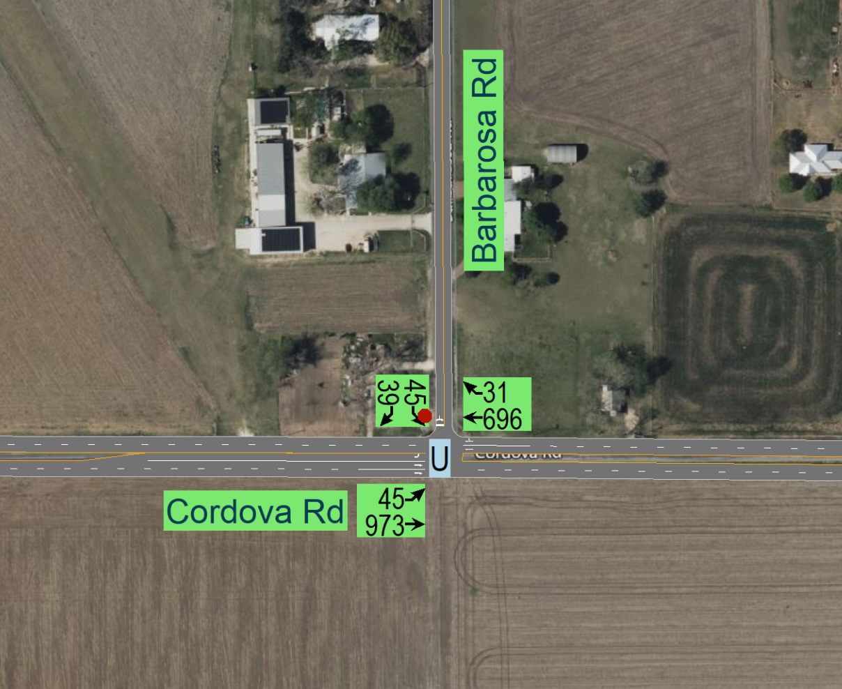
2025 AM & PM:
- Recommended lane configuration is shown in the snip above.
- Operates with an LOS A/B on Cordova Rd in AM/PM and LOS E for Barbarosa Rd for both AM/PM but there isn’t any significant queue experienced NB/SB with current lane improvements shown, as the volumes are not high enough.
- Provided dedicated right turn lane on WB if Peak Hour right turn traffic > 50vph. Currently not projecting more than 50 WB right-turns
- EB Left-turn lane should be a minimum of 200’ plus 50’ of taper based on design speed of 40 mph.

2045 AM & PM:
- Recommended lane configuration is shown in the snip above.
- Operates with an LOS B on Cordova Rd and LOS F for Barbarosa Rd in both AM and PM but there isn’t any significant queue experienced NB/SB with current lane improvements shown, as the volumes are not high enough.
- Provided dedicated right turn lane on WB as the Peak Hour right turn traffic > 50vph. Right turn lane should be a minimum 130’ in length plus 50’ of taper based on design speed of 40 mph
- .
- EB Left-turn lane should be a minimum of 200’ plus 50’ of taper based on design speed of 40 mph.

- CORDOVA RD AND HUBER RD – SIGNALIZED
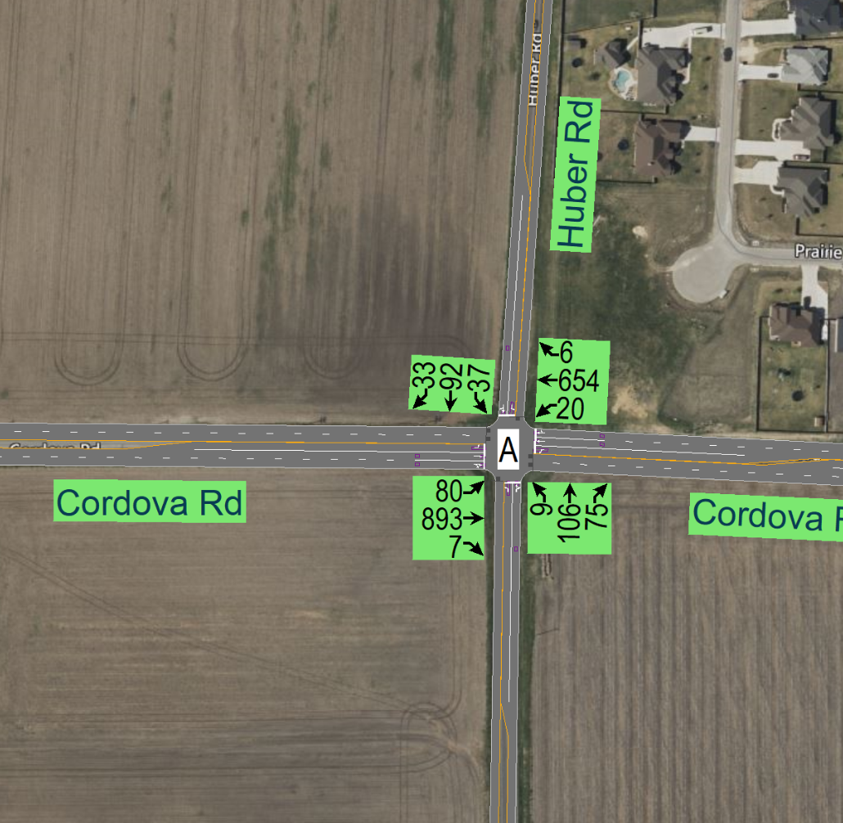
2025 AM & PM:
- Recommended lane configuration is shown in the snip above. This intersection is converted to signalized operation in both AM/PM. Not projected to meet signal warrants until after 2025.
- Operates with an overall LOS A in AM and PM with current lane and signalized improvements shown.
- Widen Huber Road to 3 lane cross section to provide separate left-turn lanes to improve signal operations and plan for future growth along Huber Road
2045 AM & PM:
- Recommended lane configuration is shown in the snip above. This intersection is converted to signalized operation in both AM/PM
- Operates with an overall LOS A in AM and PM with current lane and signalized improvements shown.
- Widen Huber Road to 3 lane cross section to provide separate left-turn lanes to improve signal operations and plan for future growth along Huber Road

- CORDOVA RD AND PRAIRIE JCT – UNSIGNALIZED
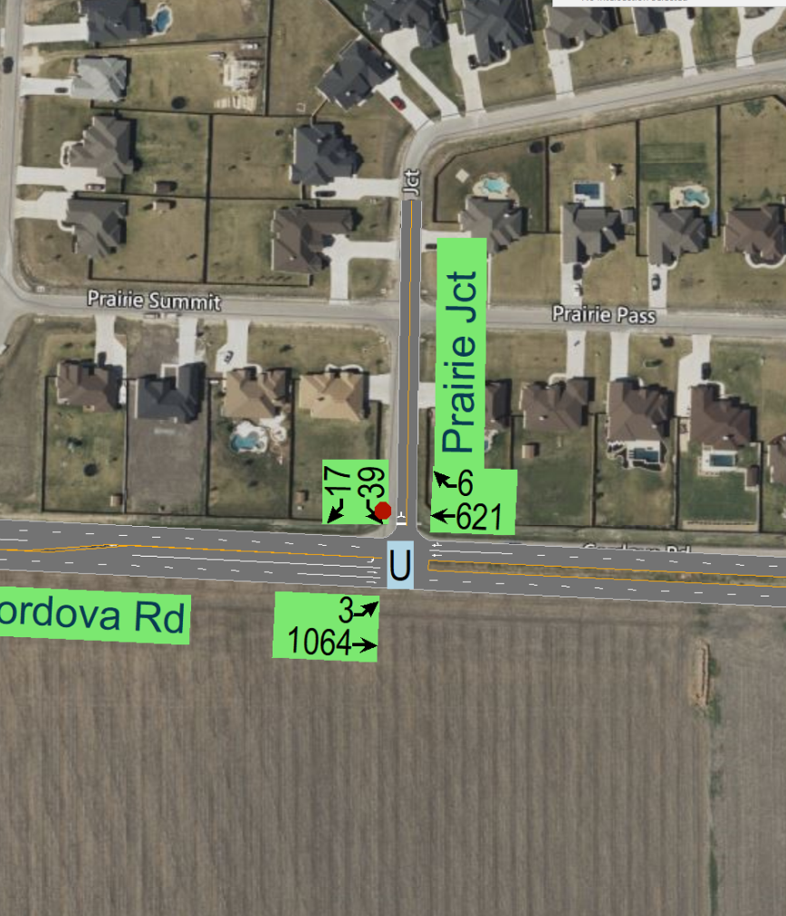
2025 AM & PM:
- Recommended lane configuration is shown in the snip above.
- Operates with an LOS A/LOS B on Cordova Rd in AM/PM. LOS is C/D in AM/PM for Prairie Jct but there isn’t any significant queue experienced NB/SB with current lane improvements shown, as the volumes are not high enough.
- EB Left turn lane should be a minimum of 200’ plus 50’ of taper based on design speed of 40 mph.
2045 AM & PM:
- Recommended lane configuration is shown in the snip above.
- Operates with an LOS A/B on Cordova Rd in AM/PM. LOS is E/F in AM/PM for Prairie Jct but there isn’t any significant queue experienced NB/SB with current lane improvements shown, as the volumes are not high enough.
- EB Left turn lane should be a minimum of 200’ plus 50’ of taper based on design speed of 40 mph.

- CORDOVA RD AND SH 123 – SIGNALIZED
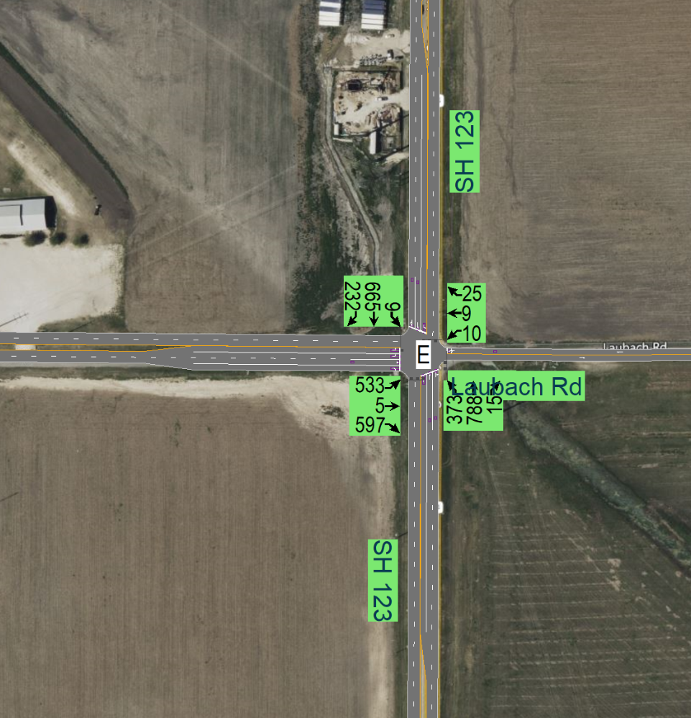
2025 AM & PM:
- Recommended lane configuration is shown in the snip above.
- Operates with an overall LOS E in AM and LOS F in PM with current lane improvements shown.
- Increasing the NB LT Lane length or providing dual left turns into Cordova Rd will help improve long queues observed on SH 123 NB LT that block thru movements. One of the eastbound left-turn lanes would need to be striped-off out until SH 123 is widened to accommodate the dual left-turn lanes.
- Additional recommendation is to increase Green time and optimize cycle lengths to improve overall delay and LOS
- EB Left-turn lanes should be a minimum 350’ in length plus 50’ of taper based on Sim Traffic Queue analysis for 40 mph design speed.
- EB Right-turn lane should be a minimum 310’ in length plus 50’ of taper based on Sim Traffic Queue analysis for 40 mph design speed.

2045 AM & PM:
- Recommended lane configuration is shown in the snip above.
- Operates with an overall LOS F in AM and PM with current lane improvements shown.
- Increasing the LT storage to 800’ with 200’ taper or providing dual LT on NB will help improve long queues observed on SH 123 that block thru movements
Another recommendation is to provide additional thru lane or shared thru left on SB 123 will help improve the long queues.

- Queue extends to almost 2560’ on EB LT. Minimum recommendation is to provide 500’ turn lane length plus 50’ of taper but it does not seem to help with the long queue which is caused by high number of right turning cars. Further discussion is required to decide if providing dual right turns at this location would be a feasible option for 2045.
- EB Right-turn lane should be a minimum 300’ in length plus 50’ of taper based on Sim Traffic Queue analysis for 40 mph design speed.
- Also recommended to increase Green time and optimize cycle lengths to improve overall delay and LOS

